INNOVATIVE TECHNOLOGY LTD
AUTOMATED TRANSACTIONS (ITL) GMBH

T2 currency manager version 3.0 instructions (Extended function version)

Note: This version only works with Windows 95.
It is only possible to upgrade the currency software in units produced after January 1997.

Installation.
1. Insert Disk 1
2. From the windows 95 explorer run a:\SETUP.EXE
3. Select the drive and directory where you want to install the software.
4. After the installation is finished a new option is added to the windows 95 start menu.

Removing.
1. Open the Windows 95 Control Panel.
2. Select Add/Remove Programs.
3. Select MANAGER.
4. Select Add/Remove...
5. The program will be removed from your system.

Operation.

1. Fit Dongle( software key ) to printer port on PC
2. Run program

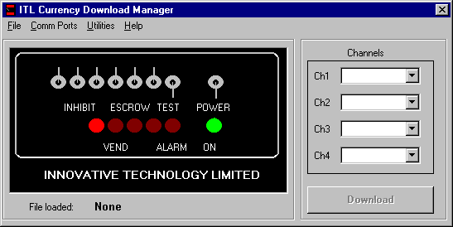

3. Select Comm. port that the Switch Box is connected to. ( This will be 1 when start the program for the first time, but if changed the program will start up on your new value)

4. Click File and Open and move to the directory where the currency files are stored

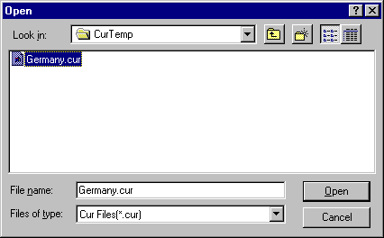

5. Click on the required file and click Open.

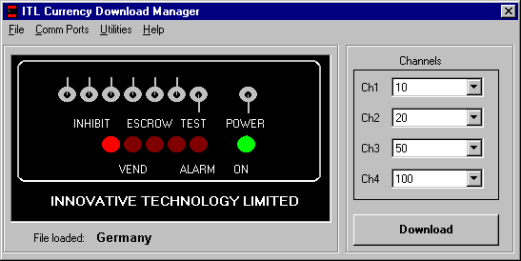

6. To download a validator, connect it to the Switch box and set switches as above.

7. The validator is now being downloaded with your selected data.

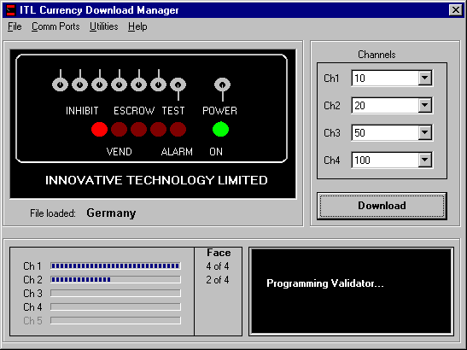

To change channel configuration.

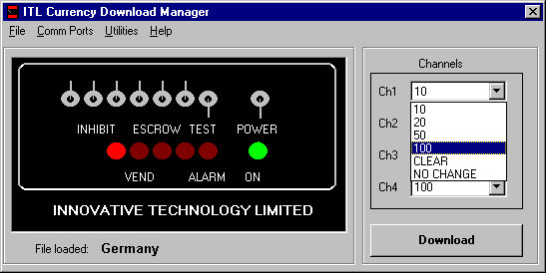

Click on required channel arrow box and select new channel configuration.
CLEAR - deletes channel
NO CHANGE - Will not alter existing channel contents.
Note that you cannot have two or more channels with the same note value ( CLEAR and NO CHANGE excepted)

Utilities

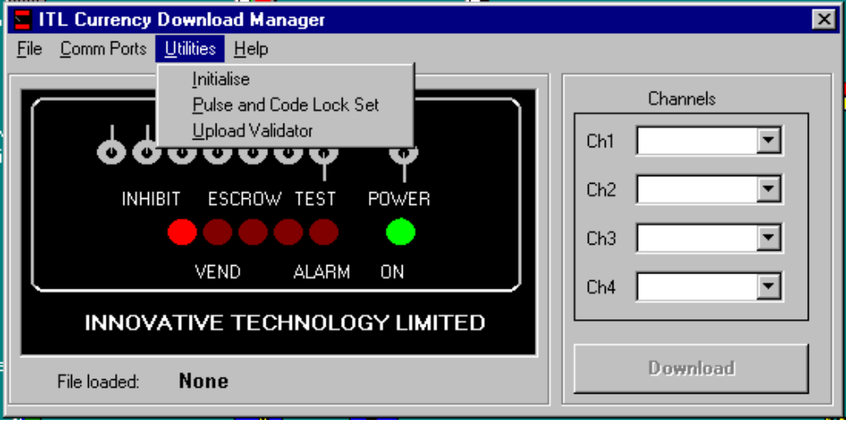

1 - Initialise
WARNING - Initialising a validator will reset it to it’s pre-calibration level and should only be carried out with consultation with ITL engineers.

Click Initialise on the menu
Connect validator using switch box configuration as shown
Click The initialise button
Press the red button on the validator
Insert the initialisation paper (letter paper quality, approx. 10 x 10 cm)
Wait for results

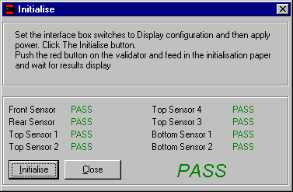

2 - Pulse and code lock set

Connect a validator to switch box as above configuration
Click Pulse and Code lock Set on menu

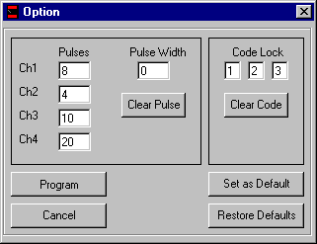

The current state of the validator is shown
The values can be changed and the validator programmed by clicking Program button.
If a large number of validators are being changed, Set up your required values and then click Set as Default button.
Your values will then appear in the boxes when you click Restore Defaults button.

Notes
Pulse width of 0 means that pulses are turned off.
Pulses should have values between 1 and 250
Pulse width should have value between 0 and 250ms

3 - Upload Validator

This utility enables a file to be created of the connected validators contents.
This is mainly for ITL engineers diagnostic purposes - a upload file can be sent to ITL in order that we can extract information about a validator.

Connect validator and power on
Click Upload on Utilities menu

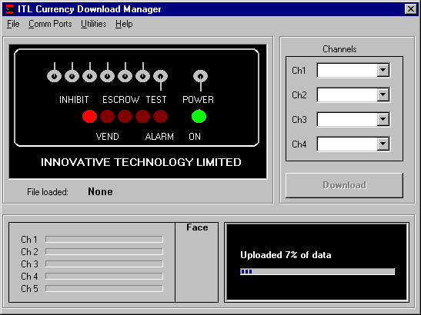

At the end of a successful upload a File Save dialogue box will appear and you can the save the file to a place of your chose

Trouble shooting.

1 - Communication Time out error
Check switch box configuration.
Check Comm. port is correctly connected to switch box and selected from The comm port menu.
Check connection to validator ( Validator switch must be at Teach)

2 - File errors

For each currency download there are two files required - *.bin and *.cur.
These files should exist in the same directory.

